Week 11 Individual Logbook
Capstone project
Matt Baker
2026
Table of Contents
Hours Breakdown 1
Completed Content/Documentation 2
Team Meetings 2
Advisor Meetings 3
Client Meetings 3
Research 3
Documentation 3
Testing 4
Development 11

Hours Breakdown
Category | Hours completed
Team meetings | 5hrs
Client meetings
Advisor meetings | 3hrs 30 min
Research | 2hrs 30 min
Development | 11hrs 45 min
Testing | 8hrs 15 min
Documentation
Logbook preparation | 1hr
Sick leave/specific conditions
Other
Total Hours for this week | 32hrs
Running total of hours completed for  Capstone | 276hrs 30min/450hrs

Completed Content/Documentation

Team Meetings
Monday, September 21
1:00-2:30 (1hr 30 mins)
Meeting with all present, we discussed what everyone had done last week, discussion on how human reporters should use all the tools at their disposal to find artefacts, even though the AI cannot. This is because the AI can be improved, but the humans are unlikely to.
Tuesday, September 22
11:30 – 12 (30min)
Auditing and compiling team logs, discussion and questions around how to approach artefacts in DF foremost examinations.
Thursday, September 24
1:00 – 3:00PM (2 hours)
Discussion on what we’ve all been working on, demonstrated csv files and json files as different ways to approach Wireshark LLM automation, agreed on script name. Designated Olivia as writing the self-review document, discussion around what is expected Dave talked about and showed off his poster. We discussed design/scale/content options around that.
Friday, September 25
10:30 – 11:30 (1hr)
Discussion on poster structure, everybody’s tasks for the day
Advisor Meetings
Tuesday, September 22
9:00-10:00AM (1hr)
Meeting with Bryce with all present, we went over some examples of project posters, discussed some project etiquette, his experiences with AUT capstone projects, I sent him some nmap scan examples but we never looked through them. Suggestions of 3 metrics, performance (nvtop, htop) as a metric.
Friday, September 25
8:00 – 10:30AM (2hr 30min)
Preparation and meeting with Bryce, discussed what we’re doing, context length restriction, CVSS. Grepping information to reduce context length. His Nmap solution, PDF python libraries to generate pdfs rather than txt files. Making a flow chart about converting to JSON normalising etc. Consolidating findings good and bad. Showing how to download free software from azure portal. Showing us Visio. Advice on poster making.

Client Meetings

Research

Documentation

Testing
Monday, September 21
3:15- 6:15PM (3 hours)
Experimenting with Retrieval Augmented Generation (RAG) which may solve the context window issue, RAG enables LLM to search within a large context/file (like an Nmap scan) to answer questions with that context in mind. I’d like to be able to ask questions about specific hosts.
Installed langchain, langchain-ollama, and langchain-chroma in a venv, also installed gemma4 and mxbai-embed-large model for embedding.
Installed and used xmlstarlet to try convert an Nmap scan to csv which obviously doesn’t work, but RAG can use text files and probably xml anyway.
I made 2 scripts based on this video: https://www.youtube.com/watch?v=E4l91XKQSgw
But unfortunately without complex parsing code it would not work with the xml format Nmap scans exist in. This code expects CSV files with comma separated values of course.
Main
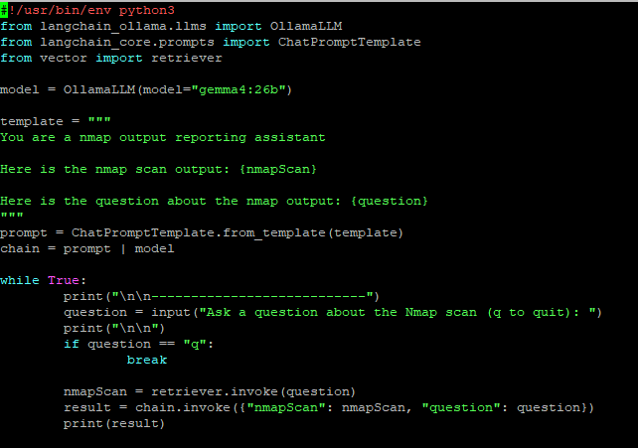
Vector (converts text into vectors (numbers that can be used to lookup data efficiently))
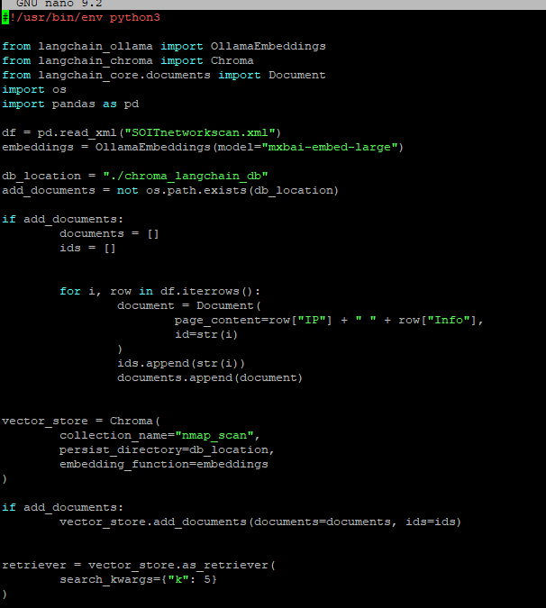

Tuesday, September 22
7:00 – 8:45 (1hr 45mins)
Doing some testing of performance recording for 3 different case files.
Installed and tested htop, tested nvtop, familiarised myself with the commands/options, searching for, killing processes via this gui, filtering results.
Running a Ninemost (Foremost AI) process on FIVE.dd (1) inspecting the VRAM load on both GPUs with nvtop (2),(3). Inspecting the regular RAM (5) usage and CPU thread load (4)
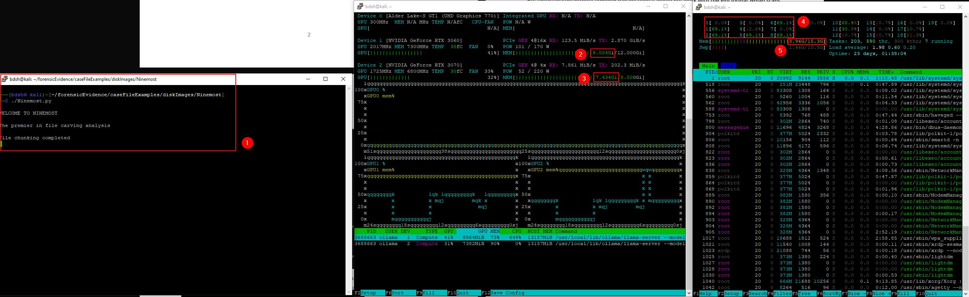
Run (1), search for (2) and find (3) my own silentcartographer script with htop
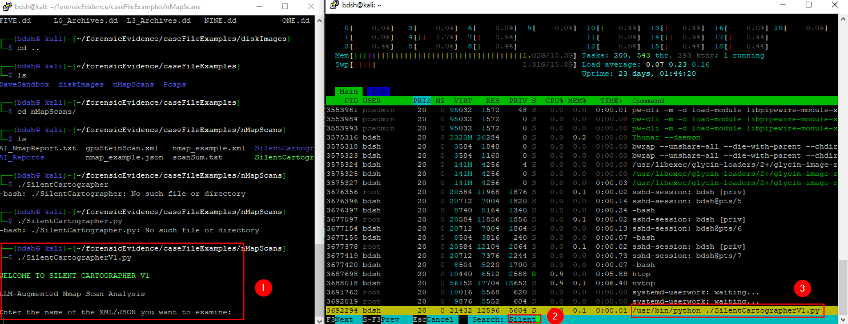
Test loads on SilentCartographerV1 script (1), inspect VRAM loads (2) sort by cpu usage and notice 99% cpu usage on ollama instance.
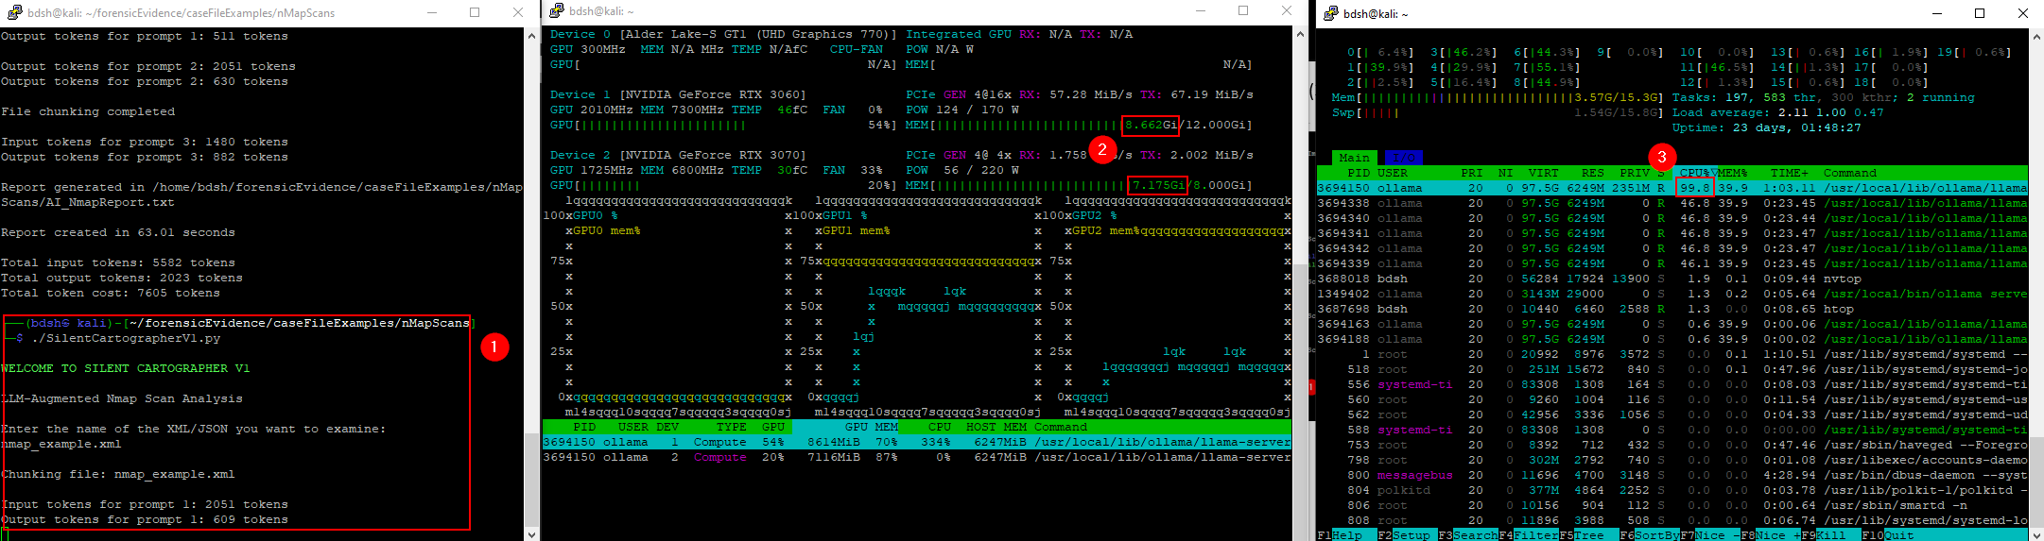
Wednesday, September 23
11:00 – 12:15 (1hr 15 mins)
Wanting to develop a solution to automate an AI augmented Wireshark packet capture analysis.
First began with converting Pcaps through Wireshark into CSV format to possibly create a RAG solution to observe, analyse, and create reports on packet captures with LLM augmentation. Also into JSON files. I also want to inspect these to see if they maintain their information within.
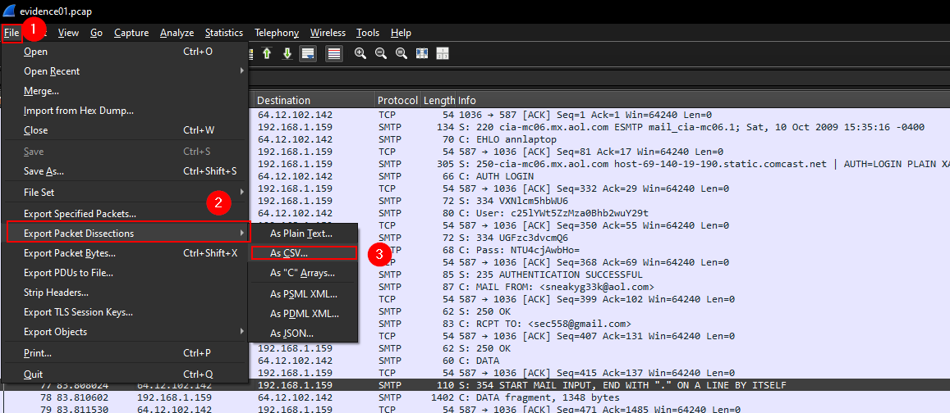
It maintains the surface level data in CSV format, with columns that can suppliment important superficial analysis through RAG but any deep packet analysis information such as that garnered from following a TCP stream is not present.
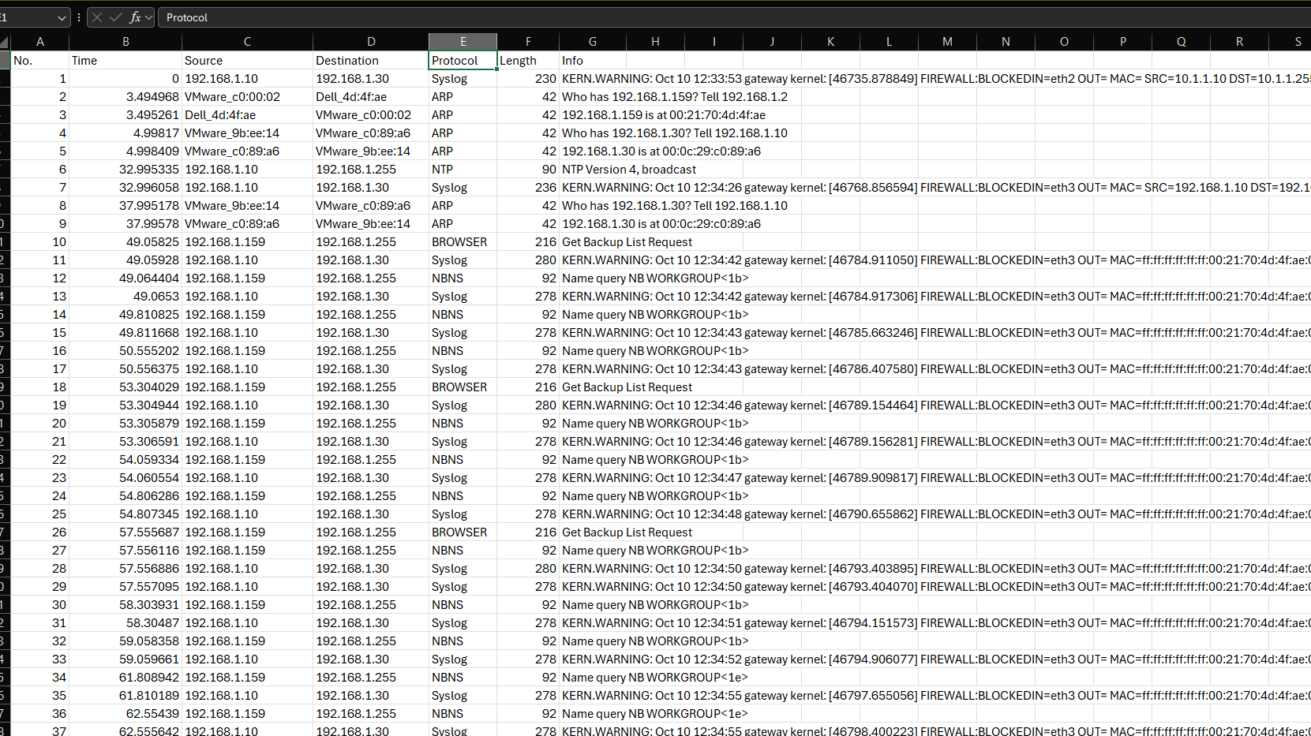

The JSON format however, though extremely long (86,408 lines) contains specific SMTP packets, the sender email (1), and specific content from within the email (2) (3). If I could somehow find a way for Ollama to consume a JSON like this efficiently, it would give an LLM an excellent shot at a comprehensive analysis.
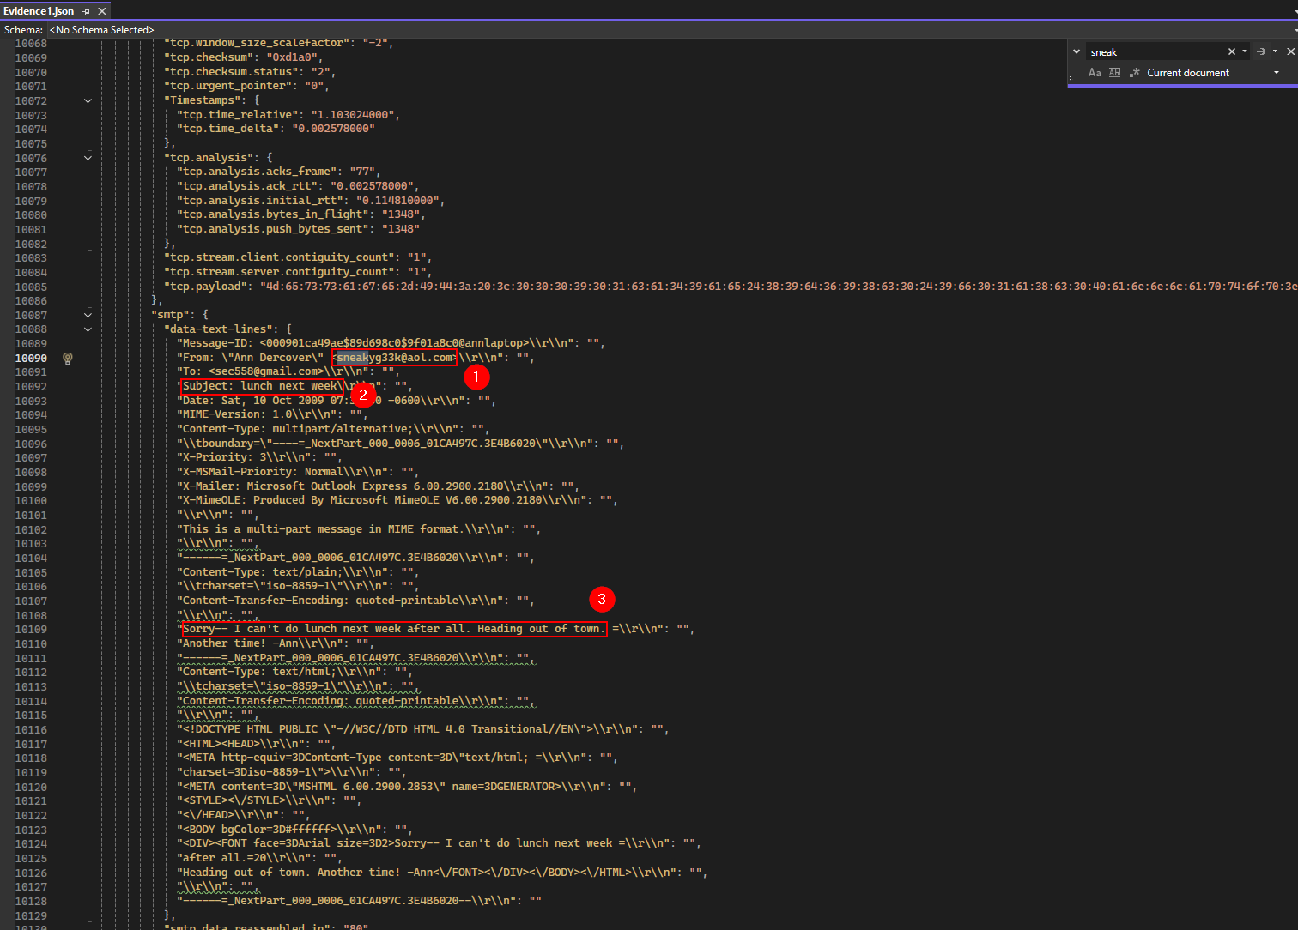
The differences in file size indicate the complexity of approach.
PCAP = 328 KB
CSV = 66KB
JSON = 4876 KB
This single example of an SMTP packet in JSON format takes 942 tokens.
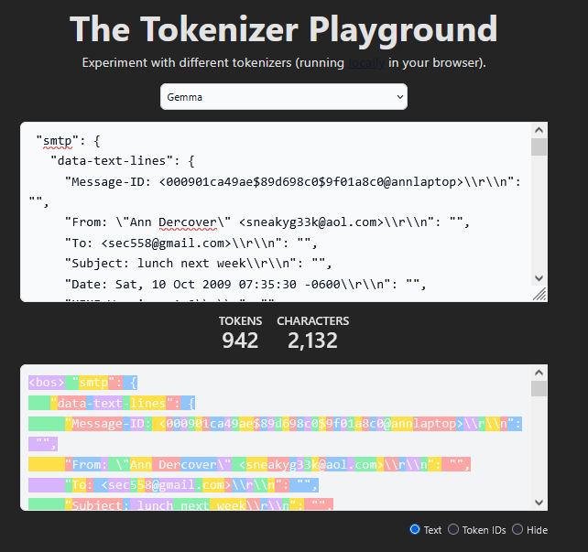
So it might be worth designing an initial solution that employs CSV files as a proof of concept.

Friday, September 25
12:45 PM – 3:00PM (2hrs 15 min)
Investigating setting context parameters with ollama
Using ollama ps, turns out ollama was only using 4k context window.
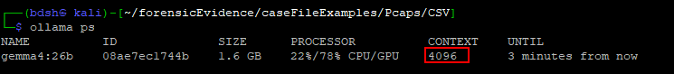
Ollama defaults to 4K context window for machines with <24gb VRAM: https://docs.ollama.com/context-length
Poor context length (1), increased context length to 8000 and then 10000 (2), improved context length (3) with higher resource usage (4).
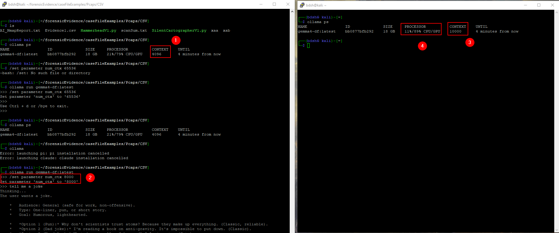
Stopped ollama, served again with increased default global context.
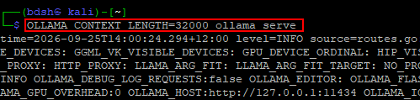
This worked but means I have to serve ollama every time I want to use it which obsolesces my work on scripts, I want it to be set through the ollama service’s environment variables.

Adding override to the ollama service to increase context length.
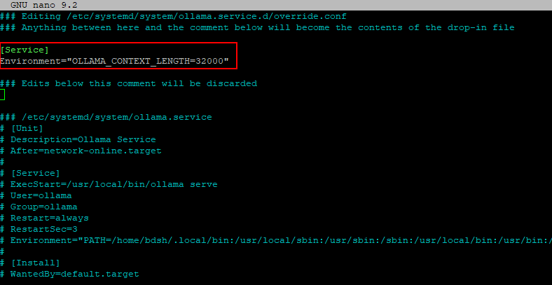
Old vs new context length
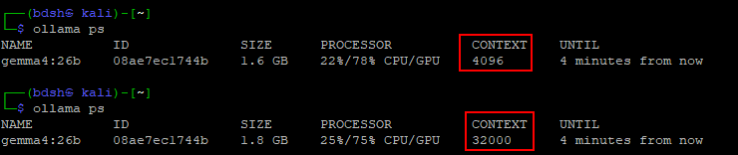
Able to inspect the totality of the SOITNetworkScan.xml file and generate a report off that, new record for single input context size.
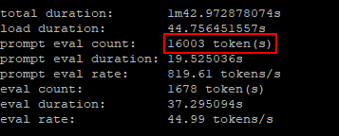

Development
Wednesday, September 23
12:15PM – 3:00PM (2hrs 45 min)
Set out to officially create reports using Ninemost.py for our 3 .dd files.
I had to update my Ninemost script to calculate token count like my SilentCartographerV1 script. Dave had done this already, but he had done this with AI, so I chose to update Ninemost myself. I also homogenised the two script’s formatting.
Spent a time afterwards fixing syntax issues like “-verbose” instead of “–verbose”, and “Text” instead of “text”.
Then, I could conduct the report generation, documentation, monitoring, and migrating files to the git.
Eight.dd
For documentation purposes, nvtop (1), active NinemostV1.py (2) and htop (3).
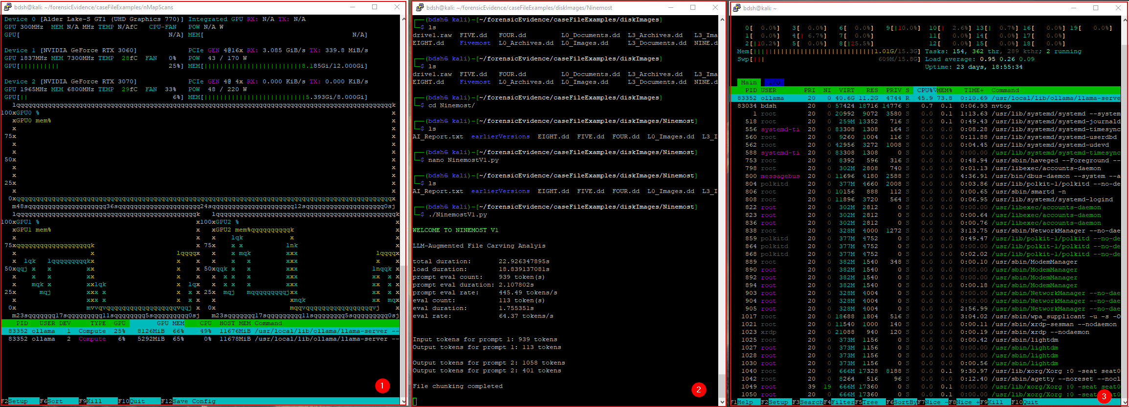
Took 68.22 seconds, cost 3856 tokens.
Three.dd
For documentation purposes, nvtop (1), active NinemostV1.py (2) and htop (3).
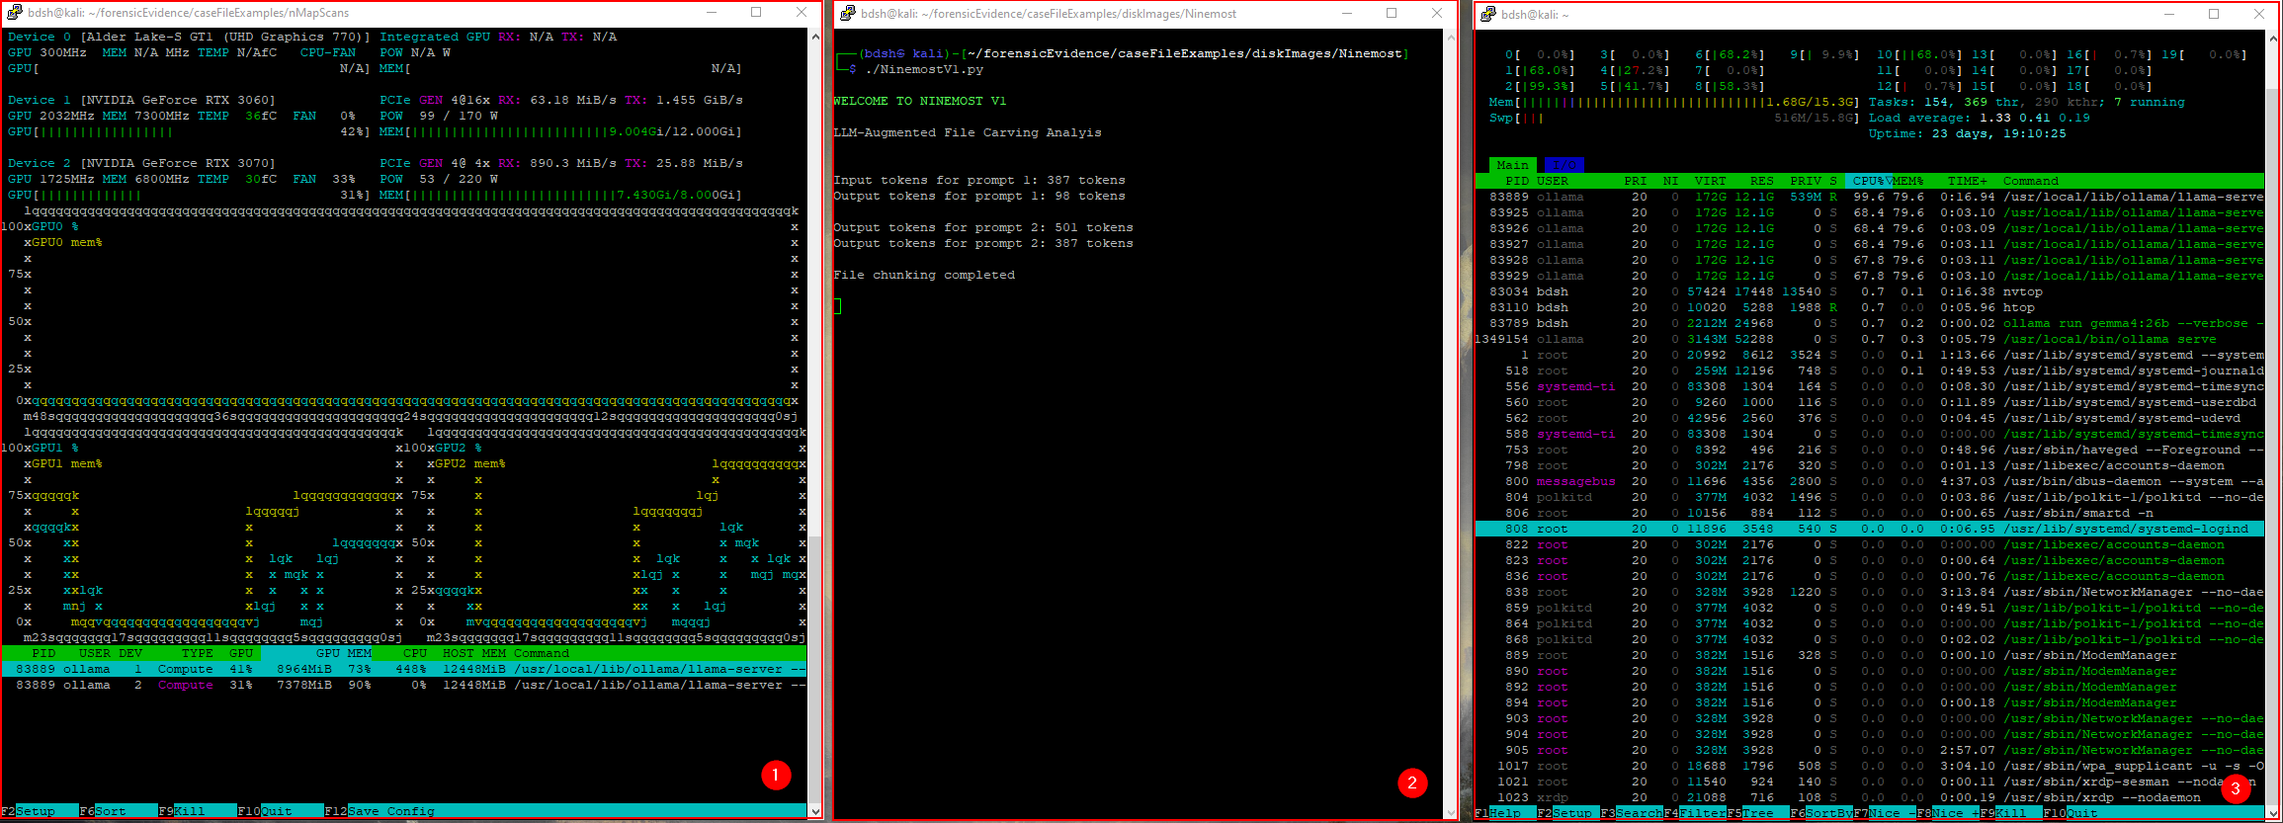
Took 64.63 seconds, cost 2669 tokens.
NINE.dd
For documentation purposes, nvtop (1), active NinemostV1.py (2) and htop (3).
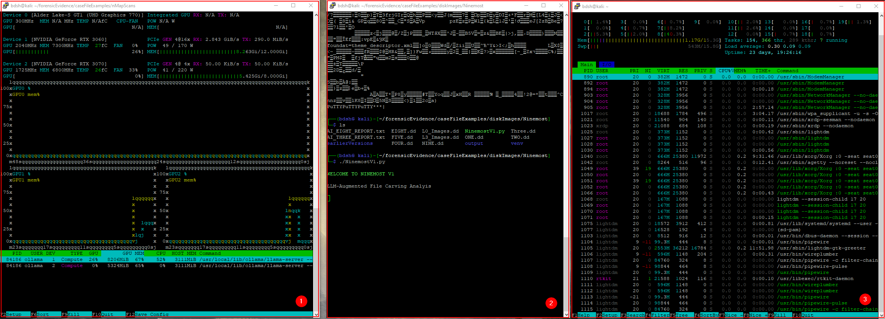
Took 69.35 seconds, cost 3831 tokens.
Thursday, 24 February
3:00 – 4:00 (1hr)
Testing CSVs and JSON files with ollama for later use with the existing Silent Cartographer V1 script.
Saturday, 26 September
3:30 – 5:30PM (2hrs)
Development of the “Hammerhead V1” script. This automates Wireshark via LLM integration.
Modified script based on previous scripts. With the new 30k context capacity over 4k.
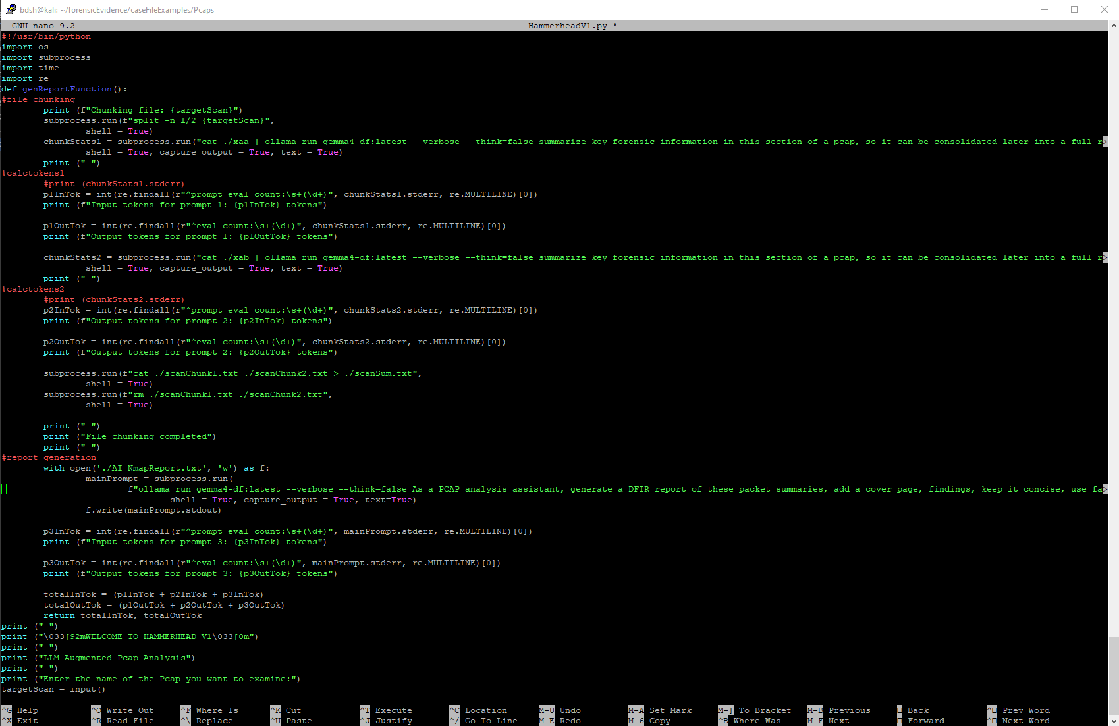

(Not the full report pictured). This report generated using CSV data actually created some decent findings and accurately identified the subject hosts, protocol, and basic traffic info.
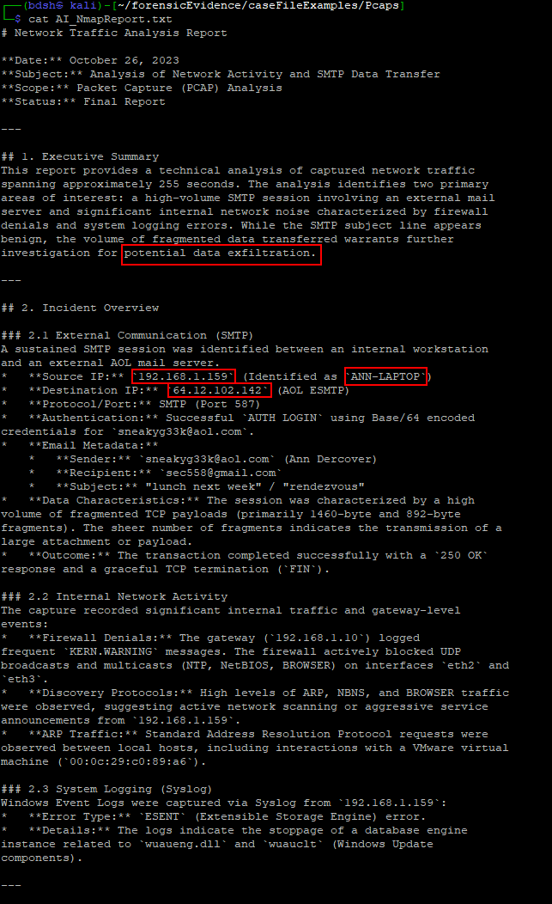

It is right in identifying the large volume of SMTP traffic, the suggestion of data exfiltration is false, however a good subject for inspection, there is just a large volume of unencrypted mail traffic because of the nature of this practice PCAP. However this kind of traffic would usually be rather anomalous. As SMTP traffic is in plain text and extremely vulnerable.
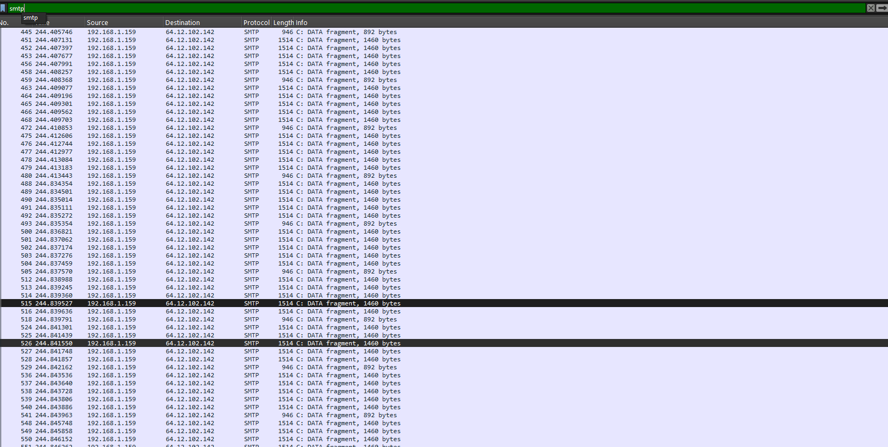
Converted the JSON file to TOON (Token-Oriented Object Notation)
The massive json format pcap is reduced in token count by only 5.8%
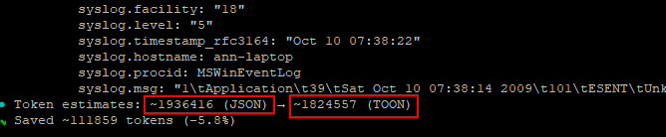
So I need to grep or awk the data in some way to extract only key data.
A grep for <DIV> will detect the lines of an email body.

Frame.number can give important investigative context
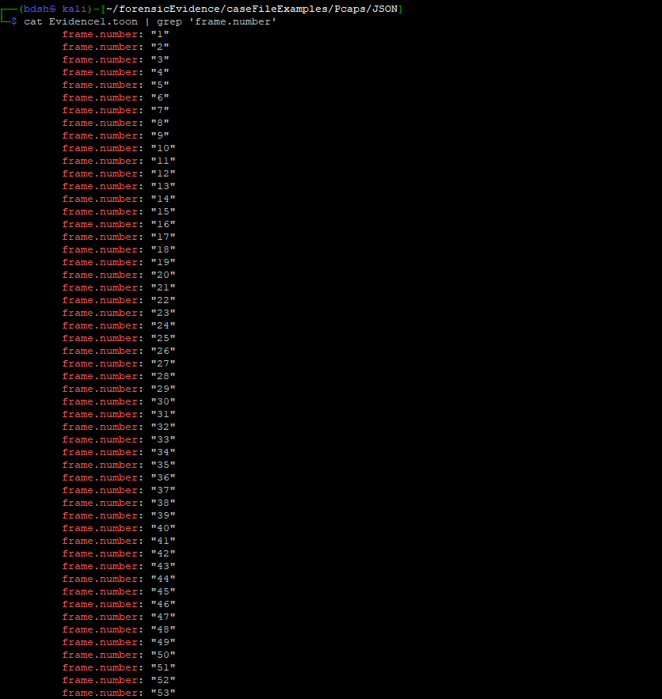

Testing grep flags -A (after) and -B (before) to see if I can give LLM full context of the smtp packet’s sender (3), receiver (4) date (2), and what packet this occurred in (1) relative to the term ‘subject’.
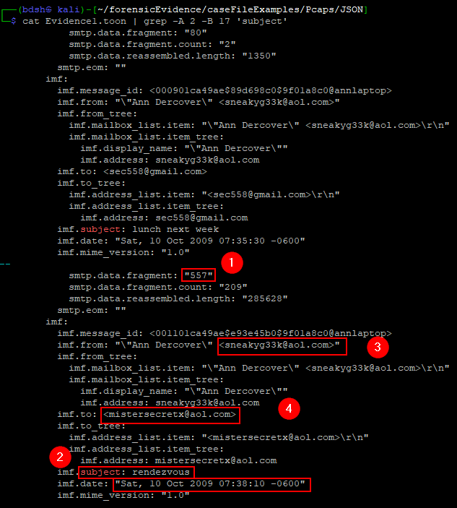
Obviously this only works when smtp content is the subject of the investigation so it is a bit flawed. We need a more universally-applicable analysis.
6:30 – 9:00PM (2hrs 30min)
Working on the same solution, I want the script to instead of making text files, make nice PDFs.
Installing fpdf2
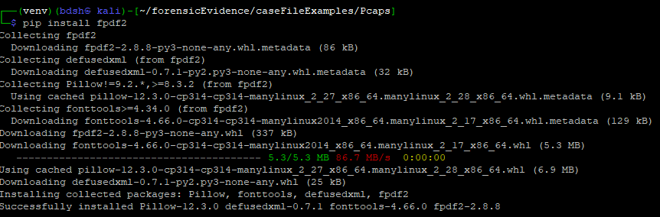’
Installing pymupdf
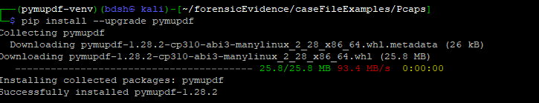
Made a script just to test the conversion functionality without having to run ollama prompts every time.
I test a simple generation command that simply says hello world which works. This means it’s something to do with reading/formatting the original report file.
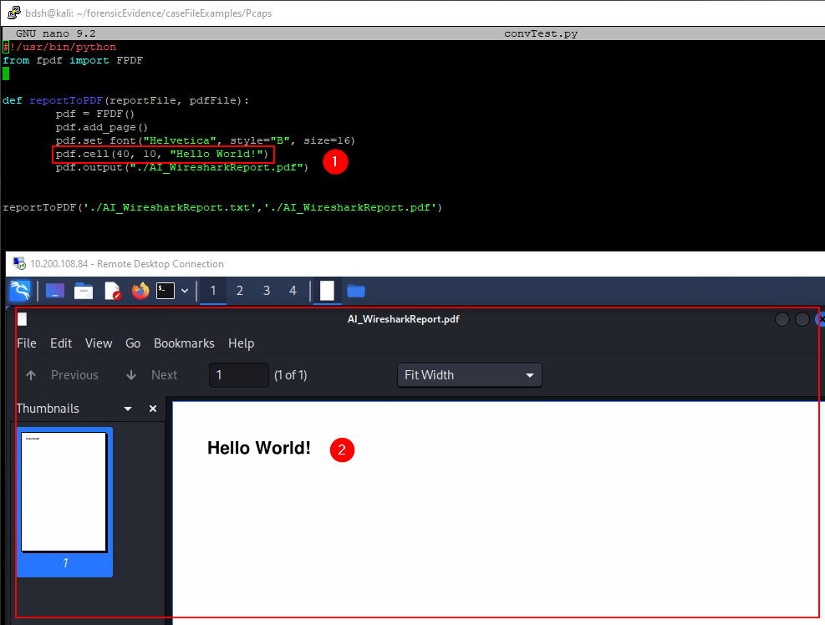
Playing around with it I kept getting this error.
It has trouble reading my reportFile variable (target AI text)
This one ended up working (both variables function)
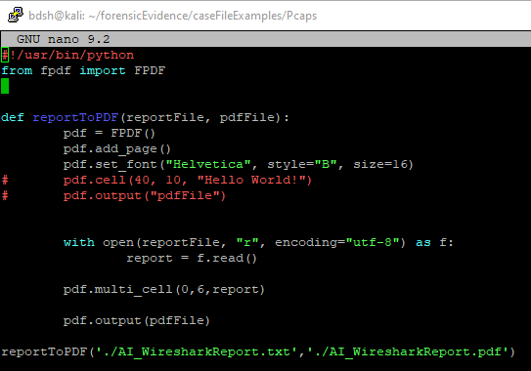

Report pdf example (notice ANSI artefacts)
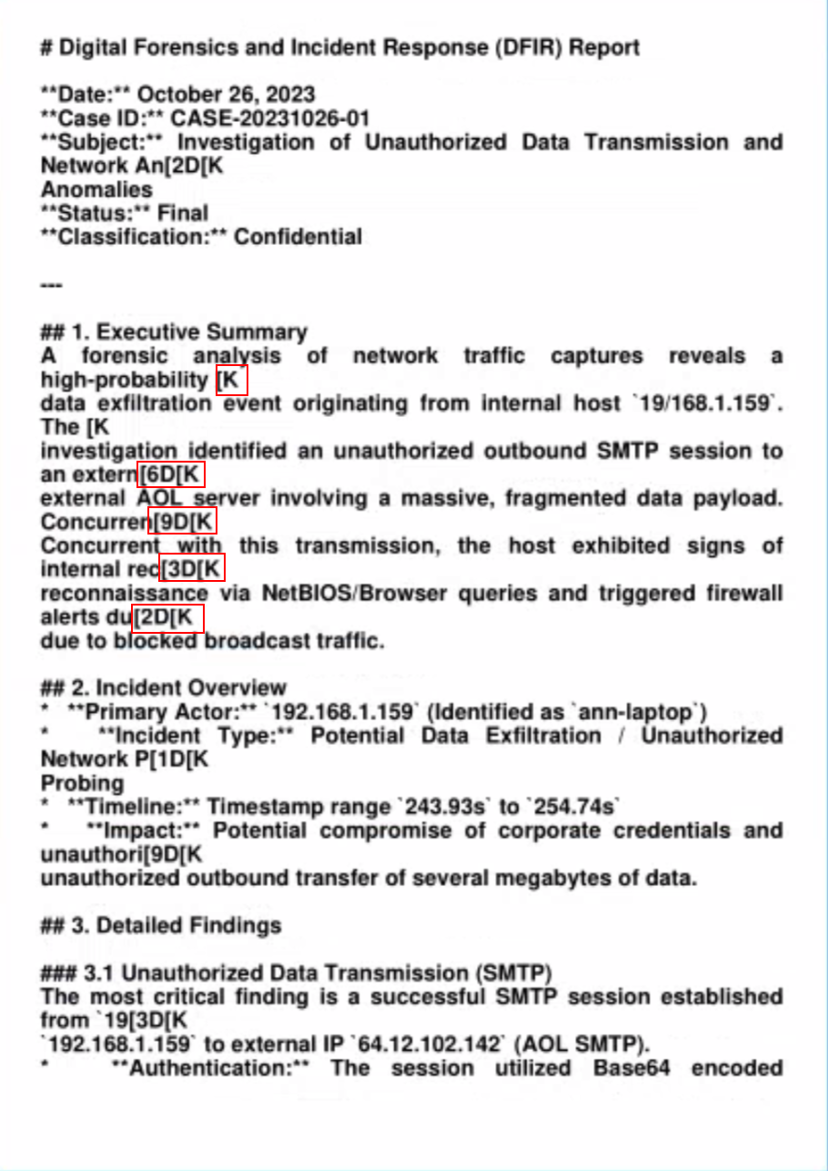
Added line that removes ANSI escape sequence artefacts
https://stackoverflow.com/questions/75904146/removing-ansi-escape-sequence-in-python
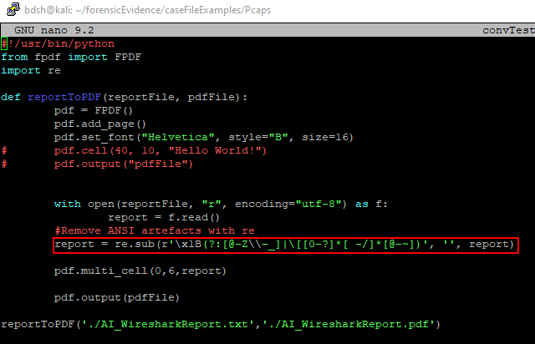
Now absent from pdf but it still looks pretty rough.
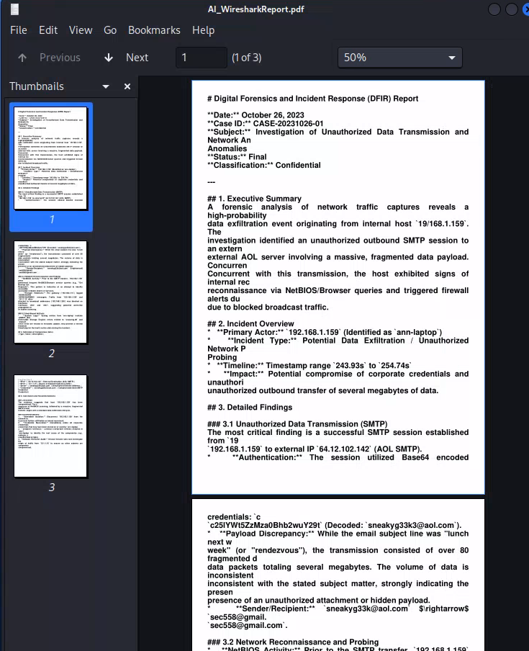
Sunday, September 27
12:00 – 3:30 (3hrs 30 min)
Implementing working fpdf code into main code
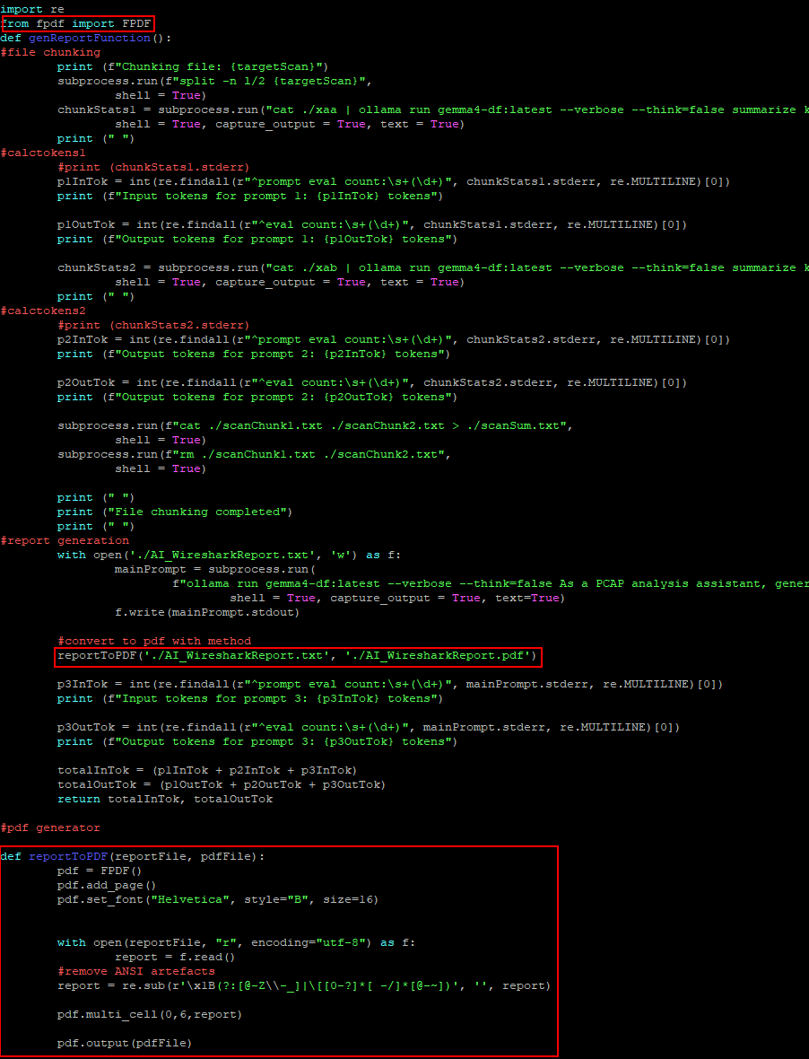
Trying to improve PDF formatting, after trying to expand the ANSI sequence removal line to also remove markdown artefacts, I realise that the markdown artefacts are actually for boldening and formatting type, so I run a quick test and simply directly convert the text as markdown to pdf with pandoc with excellent results

It preserves bulletpoints (1) selective boldening, titles (2), page numbers (3) and navigation (4) so I don’t actually have to remove all of the ** and ### and ||| present in the markdown ollama produces. It also means I don’t use fpdf anymore
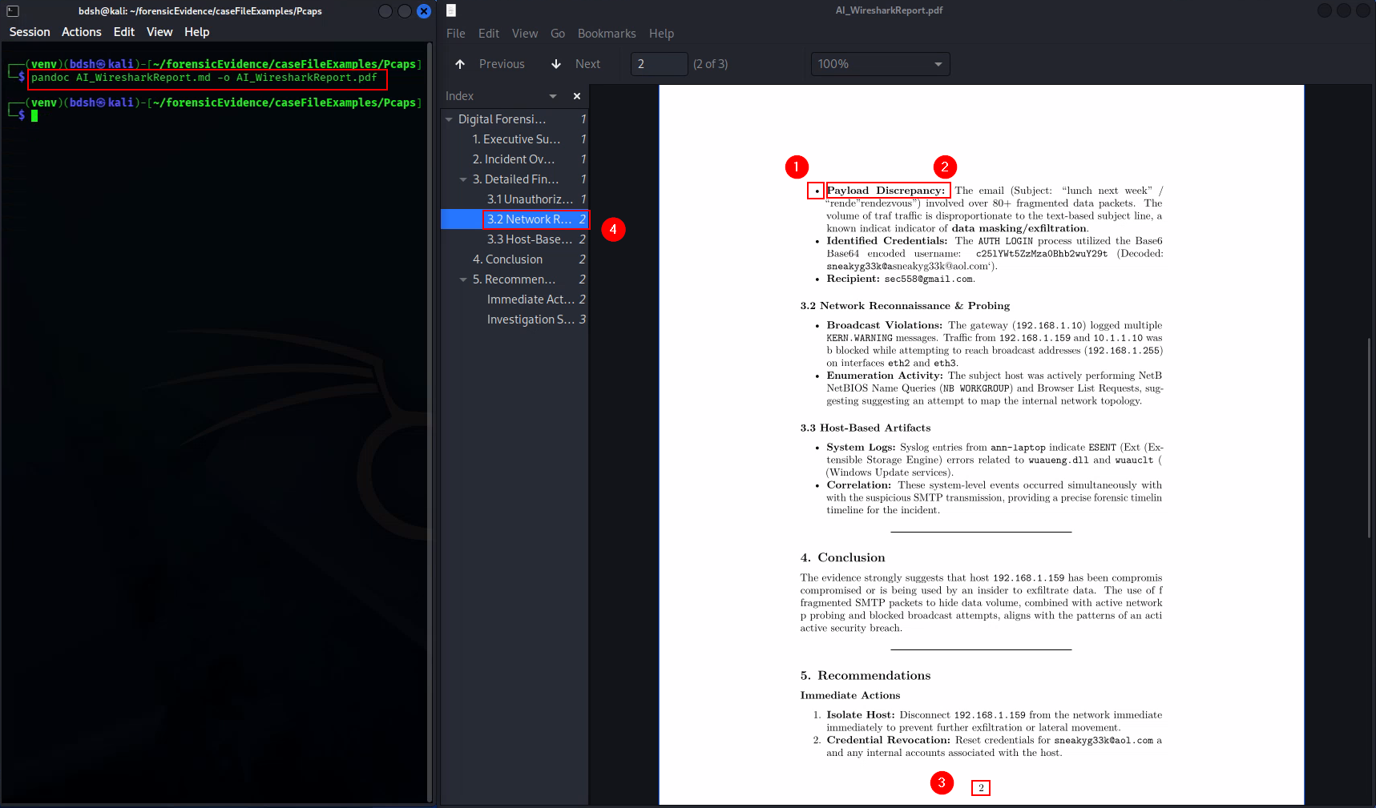
Modified pdf conversion function, it no longer uses fpdf
It reads the output .md report from ollama as “report” (1), removes the ANSI artefacts with re (2), and writes the report along with these changes to a temporary .md report instead of overwriting the original (3). It then converts the temp.md to pdf with pandoc via subprocess module.
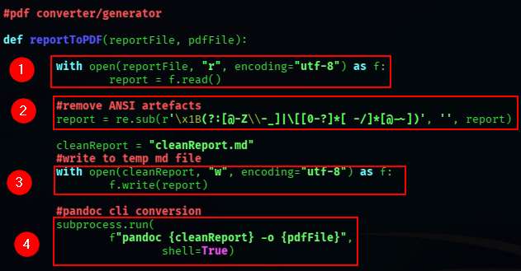

Looks good but need to truncate these spaces and asterisks (1) as well as the familiar issue with repeating text (2).
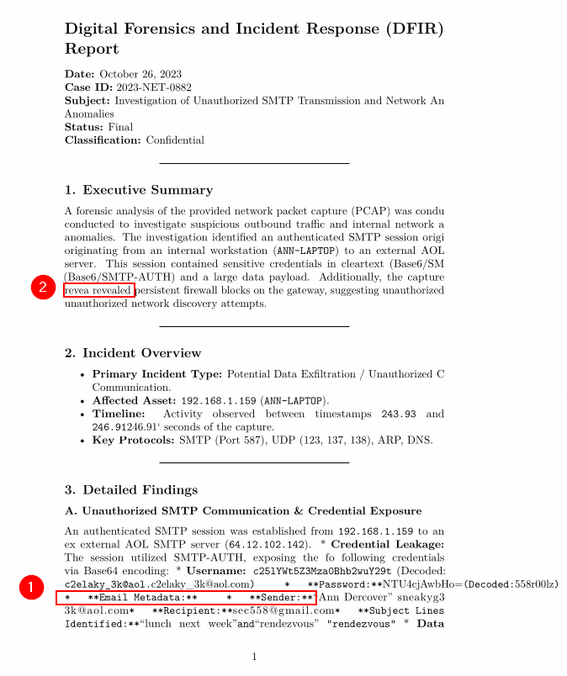
Spent a while trying to fix this with prompting, asking for “clean markdown” and without “decorative markdown” as these symbols aren’t actually doing anything
This was the best example I got without the previous issue of decorative markdown.
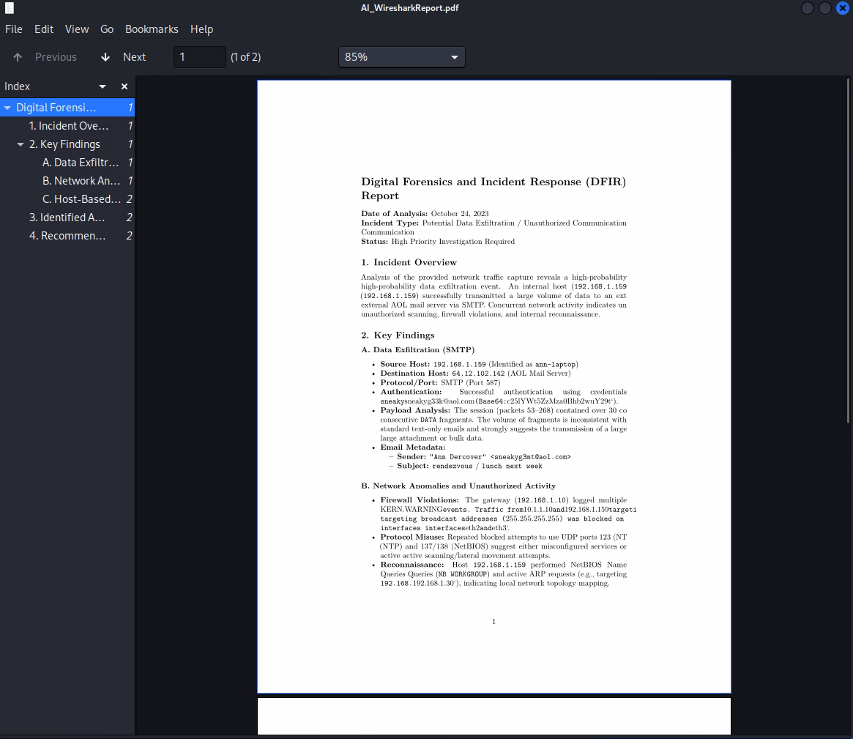
“nowordwrap” flag with ollama removes the ansi escape sequences AND the leftover parts of the line that ANSI terminal control is supposed to delete.
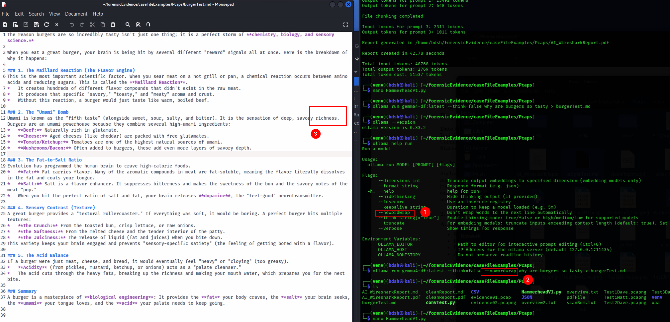
Implemented this into my script and gave the prompt a proper date too.
Excellent outcome, I think this means I don’t even need to use re to remove ANSI escape sequences.
